**FACIAL RECOGNITION**

**Project Report**

**<Version 5.0>**

MAJOR PROJECT (ICI651)

Degree

**BACHELOR OF COMPUTER APPLICATION**



M

**FACULTY OF ENGINEERING & COMPUTING SCIENCES**

**TEERTHANKER MAHAVEER UNIVERSITY, MORADABAD**

**MAY,2023**

|  |  |
| --- | --- |
| PROJECT GUIDE:  **Arshad Ali Sir** | SUBMITTED BY:  **AASHNA ALI (TCA2056001)**  **RITIK AGARWAL (TCA2056019)**  **SANDEEP SHARMA (TCA2056021)**  **TUSHAR AGARWAL(TCA2056024)** |

**DECLARATION**

We hereby declare that this Project Report titled _Facial_expression recognition system is submitted by us and approved by our project guide, Faculty of Engineering & Computing Sciences. Teerthanker Mahaveer University, Moradabad, is a bonafide work undertaken by us and it is not submitted to any other University or Institution for the award of any degree diploma / certificate or published any time before.

|  |  |  |
| --- | --- | --- |
| **Project ID :** | Project Id | |
| **Student Name:** | AASHNA ALI | TCA2056001 |
| **Student Name:** | RITIK AGARWAL | TCA2056019 |
| **Student Name:**  **Student Name:** | SANDEEP SHARMA  TUSHAR AGARWAL | TCA2056021  TCA2056024 |
|  |  |  |
| **Project Guide :** | MR. ARSHAD ALI | Signature |

Table of Contents

1 Project Title 5

2 Problem Statement 5

3 Project Description 5

3.1 Scope of the Work 5

3.2 Project Modules 5

3.3 Context Diagram (High Level) 6

4 Implementation Methodology 6

5 Technologies to be used 6

5.1 Software Platform 6

5.2 Hardware Platform 6

5.3 Tools, if any **Error! Bookmark not defined.**

6 Advantages of this Project 7

7 Assumptions, if any 7

8 Future Scope and further enhancement of the Project 7

9 Project Repository Location 7

10 Definitions, Acronyms, and Abbreviations 8

11 Conclusion 8

12 References 9

**Appendix**

**A: Data Flow Diagram (DFD)**

**B: Entity Relationship Diagram (ERD)**

**C: Use Case Diagram (UCD)**

**D: Data Dictionary (DD)**

**E: Screen Shots**

# Project Title

Facial expression recognition system

# Problem Statement

The problem statement of facial expression detection systems is to accurately detect and interpret facial expressions from images or video footage. Facial expressions can convey a wide range of emotions, and detecting them accurately can be challenging due to various factors such as lighting, pose, occlusions, and variability in expressions across individuals.

Facial expression detection systems aim to address this problem by using computer vision and machine learning techniques to detect and analyze facial expressions. However, several challenges can affect the accuracy of the system, such as age, gender, and ethnicity bias, limited datasets, complex facial expressions, and privacy concerns.

The primary goal of facial expression detection systems is to improve human interaction and experience by accurately interpreting emotions and responding accordingly. These systems can have applications in various domains, such as healthcare, education, security, and marketing, where understanding human emotions is essential

# Project Description

A facial emotion detection system is a technology that uses computer vision and machine learning algorithms to detect and analyze facial expressions in images or video footage. The system can recognize various facial expressions, such as happiness, sadness, anger, fear, surprise, and disgust, and provide an emotional analysis of the individual's face.

Facial emotion detection systems typically use a combination of feature extraction techniques and machine learning algorithms to analyze facial expressions. The system first extracts features from the face, such as the position and movement of facial muscles, and then uses machine learning algorithms to classify the facial expression based on the extracted features.

Facial emotion detection systems have several applications, such as improving human-computer interaction, market research, healthcare, security, and education. For example, in healthcare, facial emotion detection systems can be used to monitor patient emotions and mental health, while in education, the system can be used to monitor student engagement and attention.

## Scope of the Work

* 1. Human-Computer Interaction: Facial expression detection systems can be used to improve human-computer interaction. For example, a computer can detect a user's facial expressions and respond accordingly, such as adjusting the volume of music based on the user's emotions.
* 2. Market Research: Facial expression detection systems can be used in market research to analyze consumer emotions and reactions to products or advertisements. This information can be used to develop more effective marketing strategies.
* 3. Health Care: Facial expression detection systems can be used in health care to monitor patient emotions and mental health. For example, the system can be used to detect signs of depression or anxiety.
* 4. Security and Surveillance: Facial expression detection systems can be used in security and surveillance to detect suspicious behavior or identify individuals based on their facial expressions.
* 5. Education: Facial expression detection systems can be used in education to monitor student engagement and attention. For example, a teacher can use the system to detect when a student is struggling to understand a concept.
* Overall, the scope of facial expression detection systems is vast and can be applied in various domains to improve human interaction, market research, healthcare, security, surveillance, and education.

## Project Modules

* Face recognition module
* Direction detector
* Objects counter

## Context Diagram (High Level)

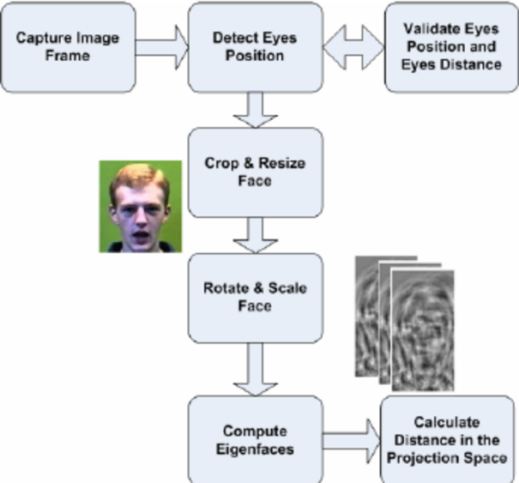

# Implementation Methodology

A computer analyzes [image data](https://summalinguae.com/data-solutions/video-and-image-collection/) and looks for a very specific set of markers within it – everything from a person’s head shape to the depth of their eye sockets.

A database of facial markers is created, and an image of a face that shares a critical threshold of similarity from database indicates a possible match. This is the basic principle behind all types of facial recognition, from unlocking your iPhone by scanning your face, to intercepting known shoplifters as they enter a store.

# Technologies to be used

## Software Platform

* **Python idle 3.11.0**

**Required Libraries.**

* **Opencv**
* **Tensorflow**
* **OS**

## Hardware Platform

RAM:- 4 gb atleast in the system.

SETUP:-normal pc with working.

# Advantages of this Project

#### **Efficient security**

Facial recognition is a quick and efficient verification system. It is faster and more convenient compared to other biometric technologies like fingerprints or retina scans. There are also fewer touchpoints in facial recognition compared to entering passwords or PINs. It supports multifactor authentication for additional security verification.

#### **Improved accuracy**

Facial recognition is a more accurate way to identify individuals than simply using a mobile number, email address, mailing address, or IP address. For example, most exchange services, from stocks to cryptos, now rely on facial recognition to protect customers and their assets.

# Assumptions, if any

NONE

# Future Scope and further enhancement of the Project

The future innovation in emotion recognition will allow machines to understand how people feel, which is the first step for them to fulfil our needs.

In future the project will be used as a automation service.

# Project Repository Location

| **S#** | **Project Artifacts (softcopy)** | **Location** (Mention Lab-ID, Server ID, Folder Name etc.) | **Verified by Project Guide** | **Verified by Lab In-Charge** |
| --- | --- | --- | --- | --- |
|  | Project Synopsis Report (Final Version) |  | ARSHAD ALI SIR |  |
|  | Project Progress updates |  | ARSHAD ALI SIR |  |
|  | Project Requirement specifications |  | ARSHAD ALI SIR |  |
|  | Project Report (Final Version) |  | ARSHAD ALI SIR |  |
|  | Test Repository |  | ARSHAD ALI SIR |  |
|  | Project Source Code (final version) with executable |  | ARSHAD ALI SIR |  |
|  | Any other document |  | ARSHAD ALI SIR |  |

# Definitions, Acronyms, and Abbreviations

|  |  |
| --- | --- |
| **Abbreviation** | **Description** |
| NIL |  |
| NIL |  |
| NIL |  |
| NIL |  |

# Conclusion

In conclusion, facial recognition systems have become increasingly popular in recent years due to significant advancements in artificial intelligence and machine learning technologies. While these systems offer many benefits such as improving security, enhancing customer service, and facilitating government services, concerns around privacy, bias and accuracy, and potential misuse and abuse continue to be debated. It is important that facial recognition applications are designed and implemented with transparency, accountability, ethical considerations, and strong regulation to ensure that they are not violating privacy rights or perpetuating discrimination. As the technology evolves, it is crucial to strike a balance between the benefits and risks and to work towards creating a more equitable and just society.

# 

# References

|  |  |  |  |  |
| --- | --- | --- | --- | --- |
| **S#** | **Reference Details** | **Owner** | **Version** | **Date** |
|  | Project Synopsis | <Project Group ID> | 1.0 | DD-MM-YY |
|  | Project Requirements | <Project Group ID> |  |  |
|  |  |  |  |  |

**Annexure A**

**Data Flow Diagram (DFD)**

**(Mandatory)**

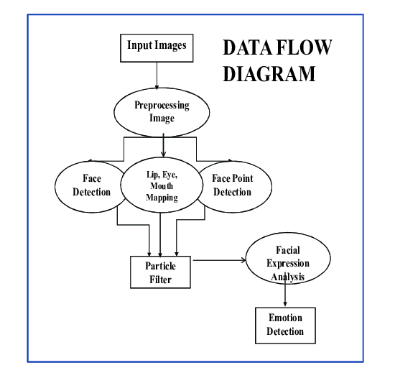

**Annexure B**

**Entity-Relationship Diagram (ERD)**

**(Mandatory)**

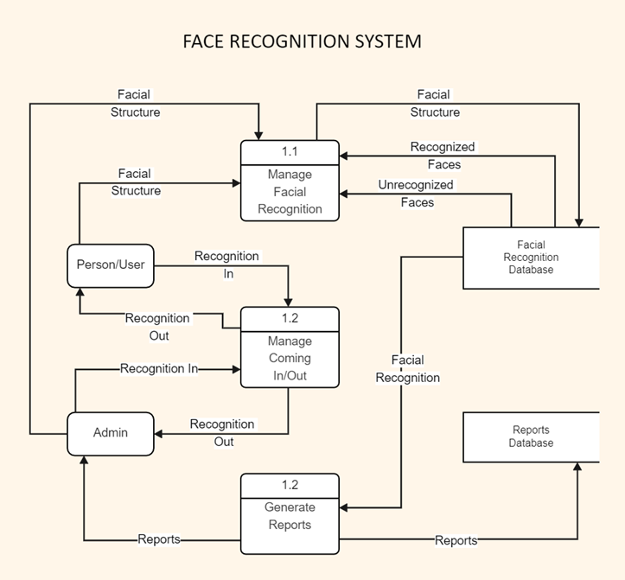

**Annexure C**

**Use-Case Diagram (UCD)**

**(Optional)**

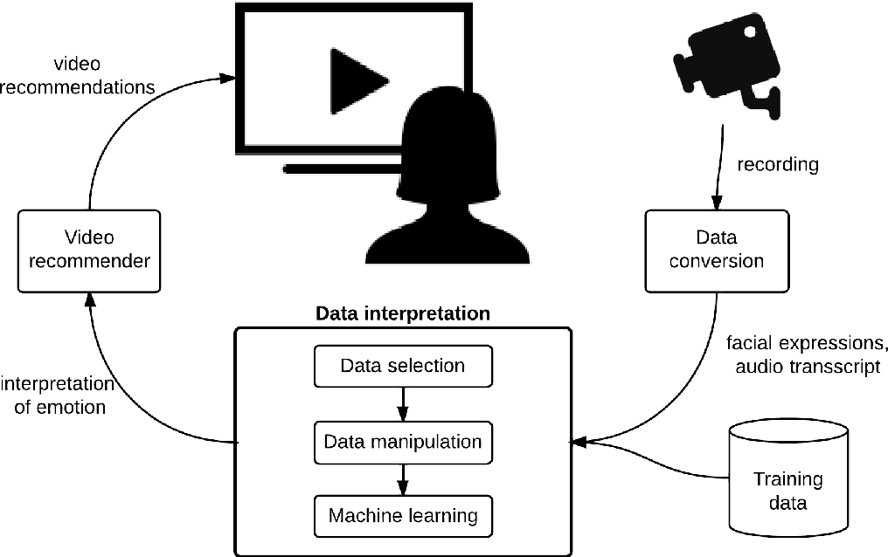

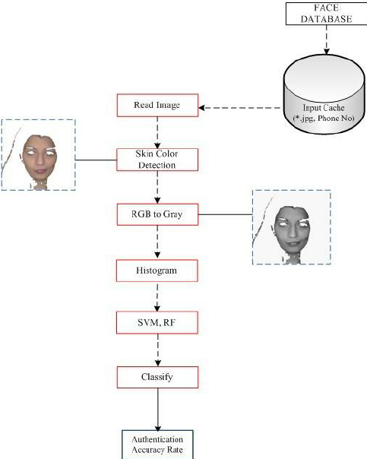**Annexure D**

**Data Dictionary (DD)**

**(Mandatory)**

**Annexure E**

**Screen Shots**

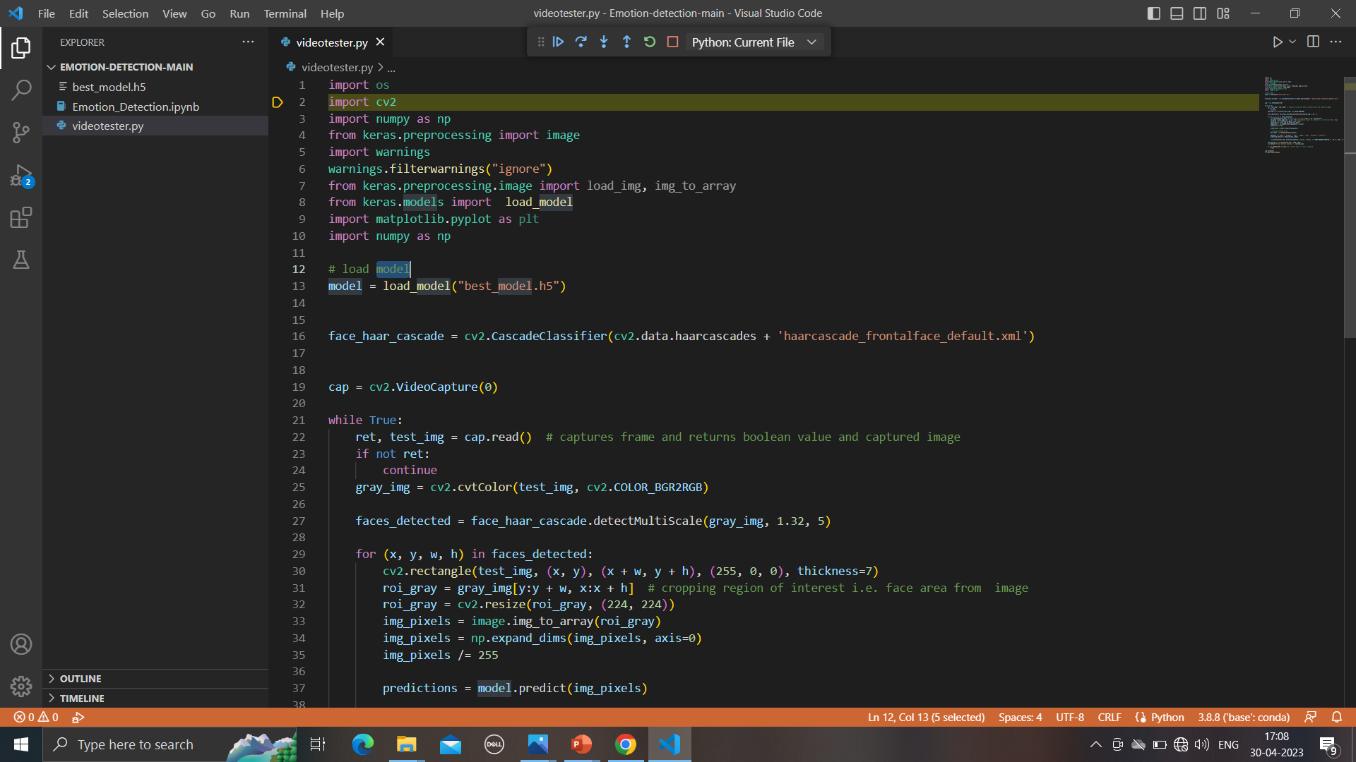

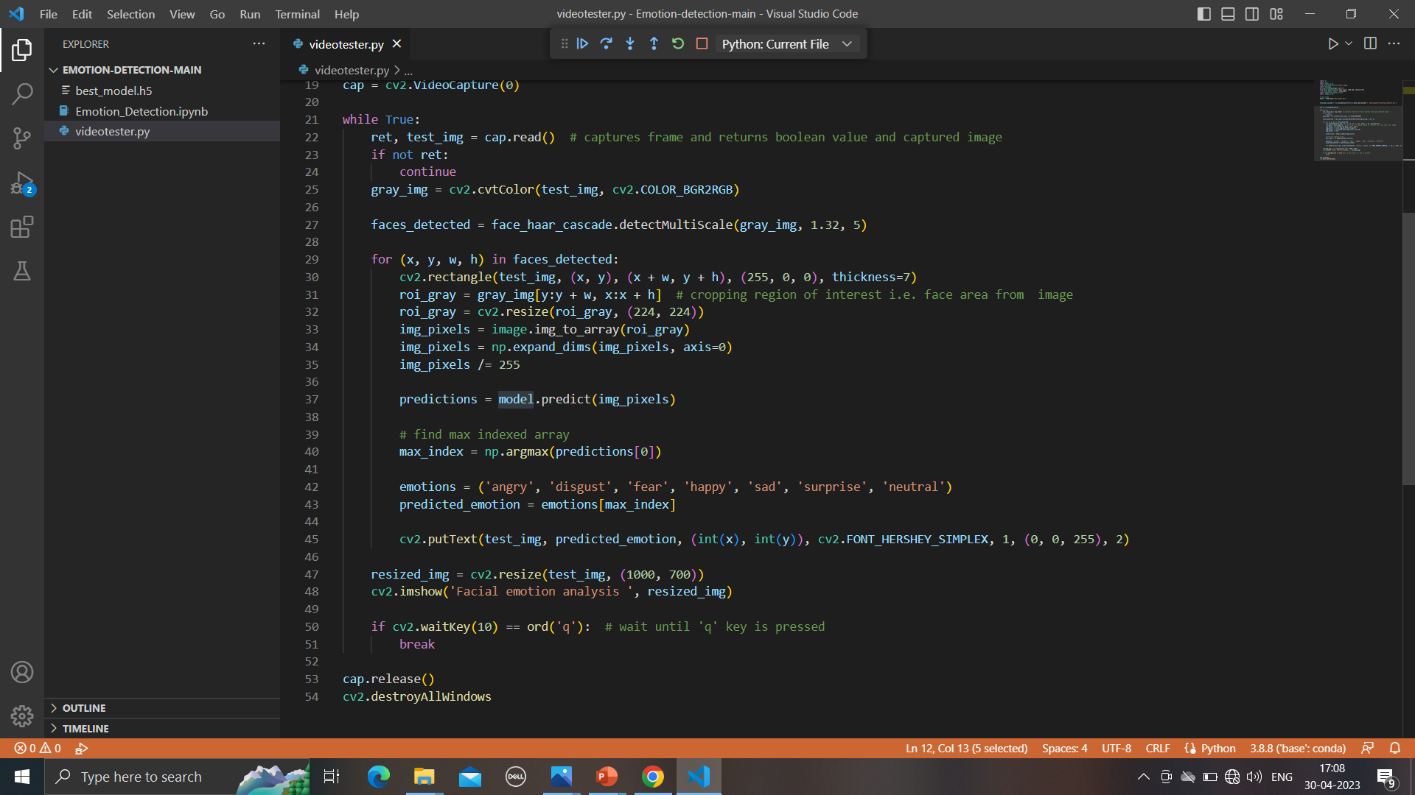

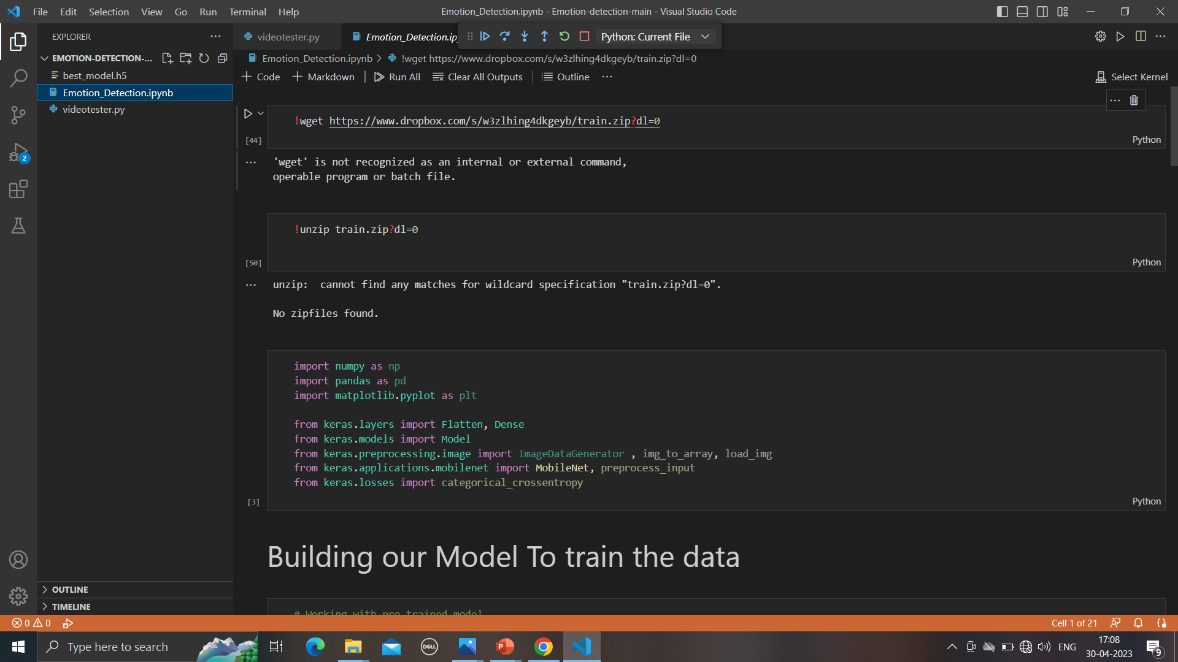

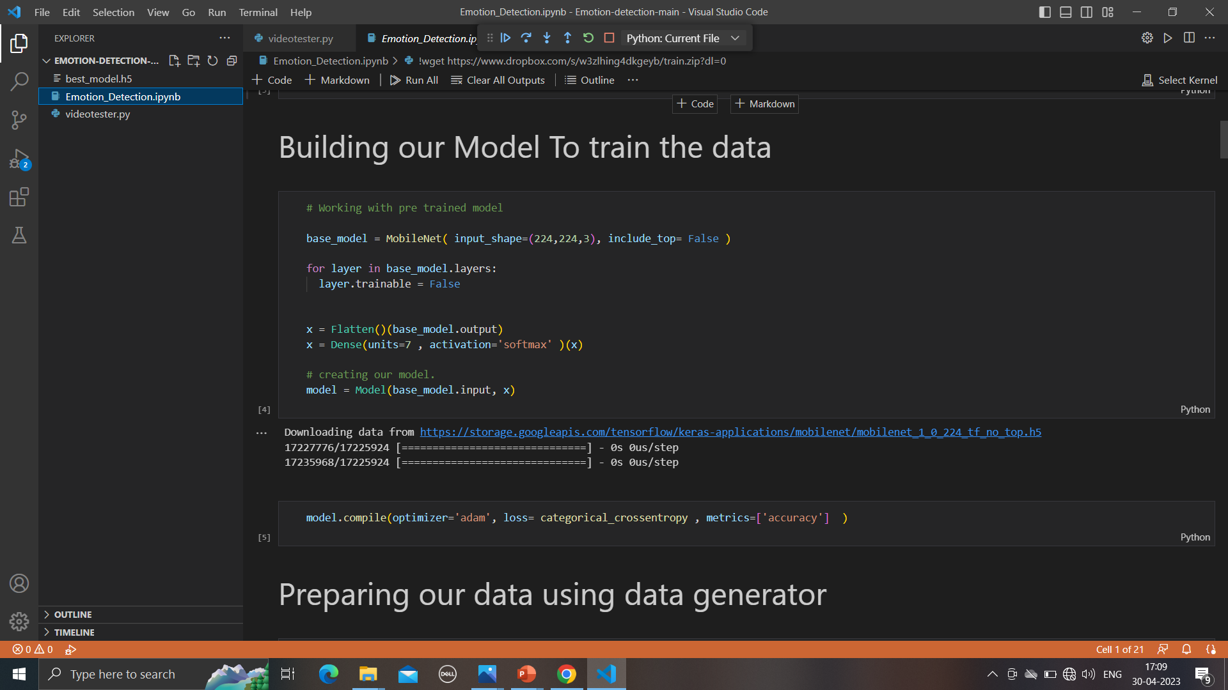

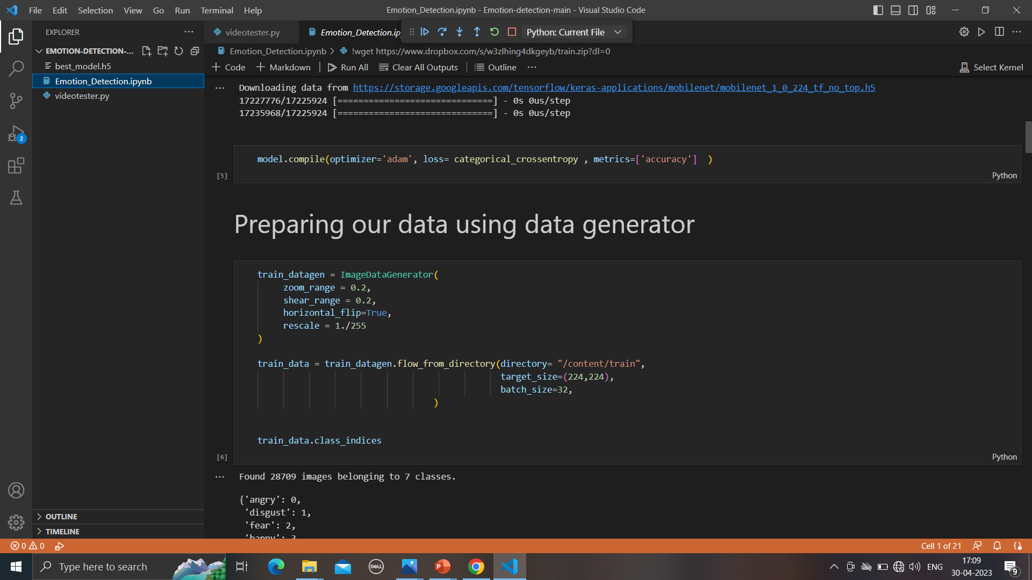

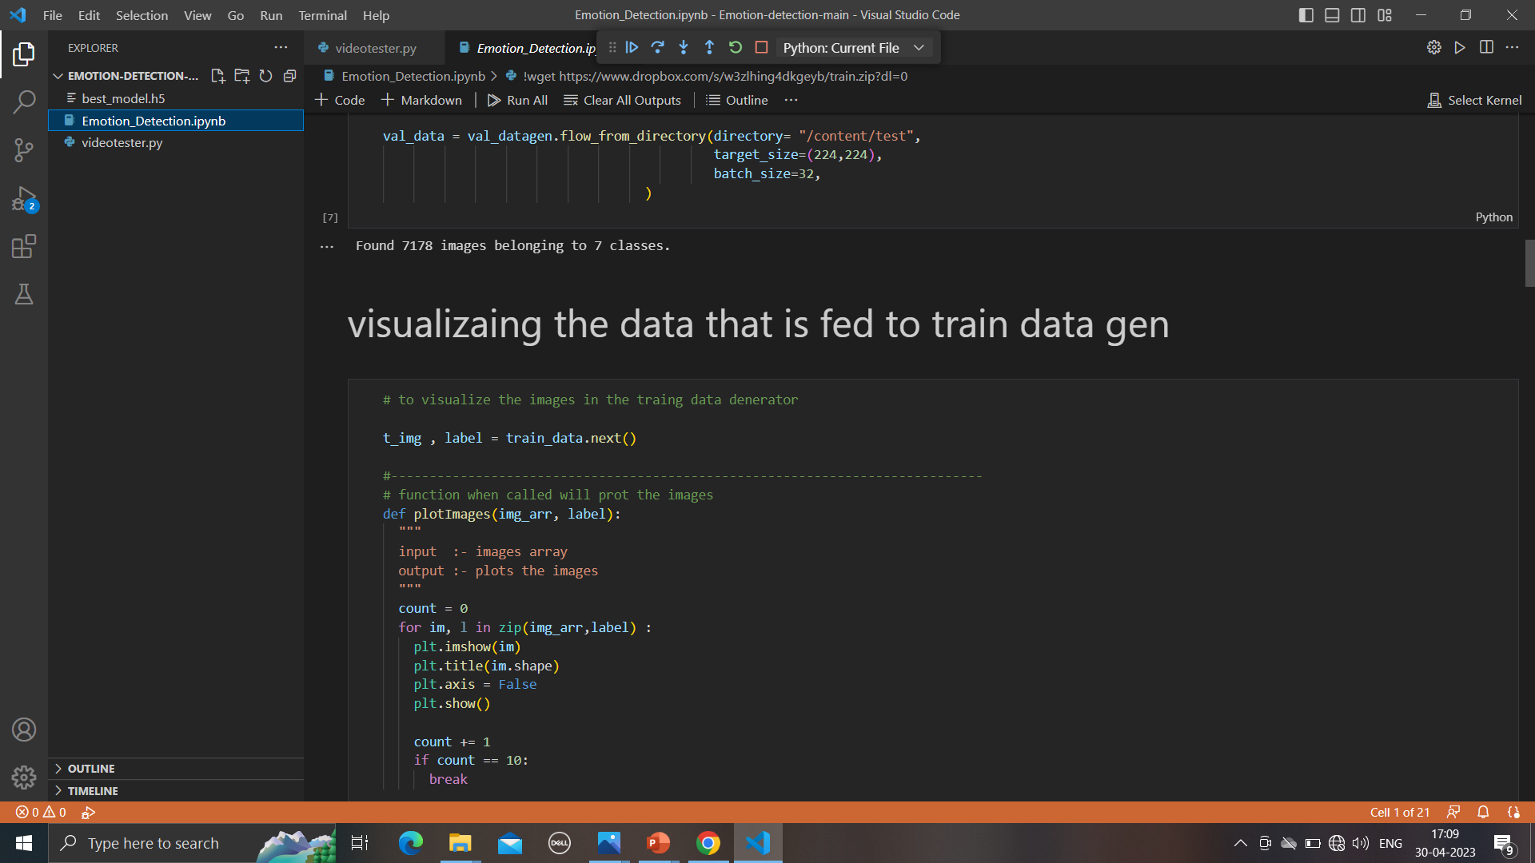

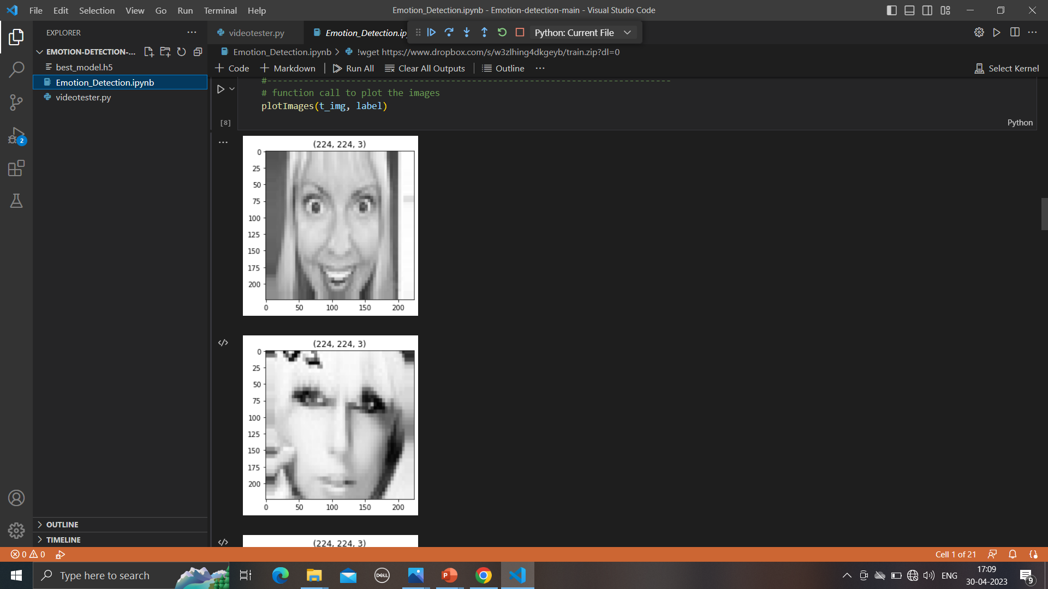

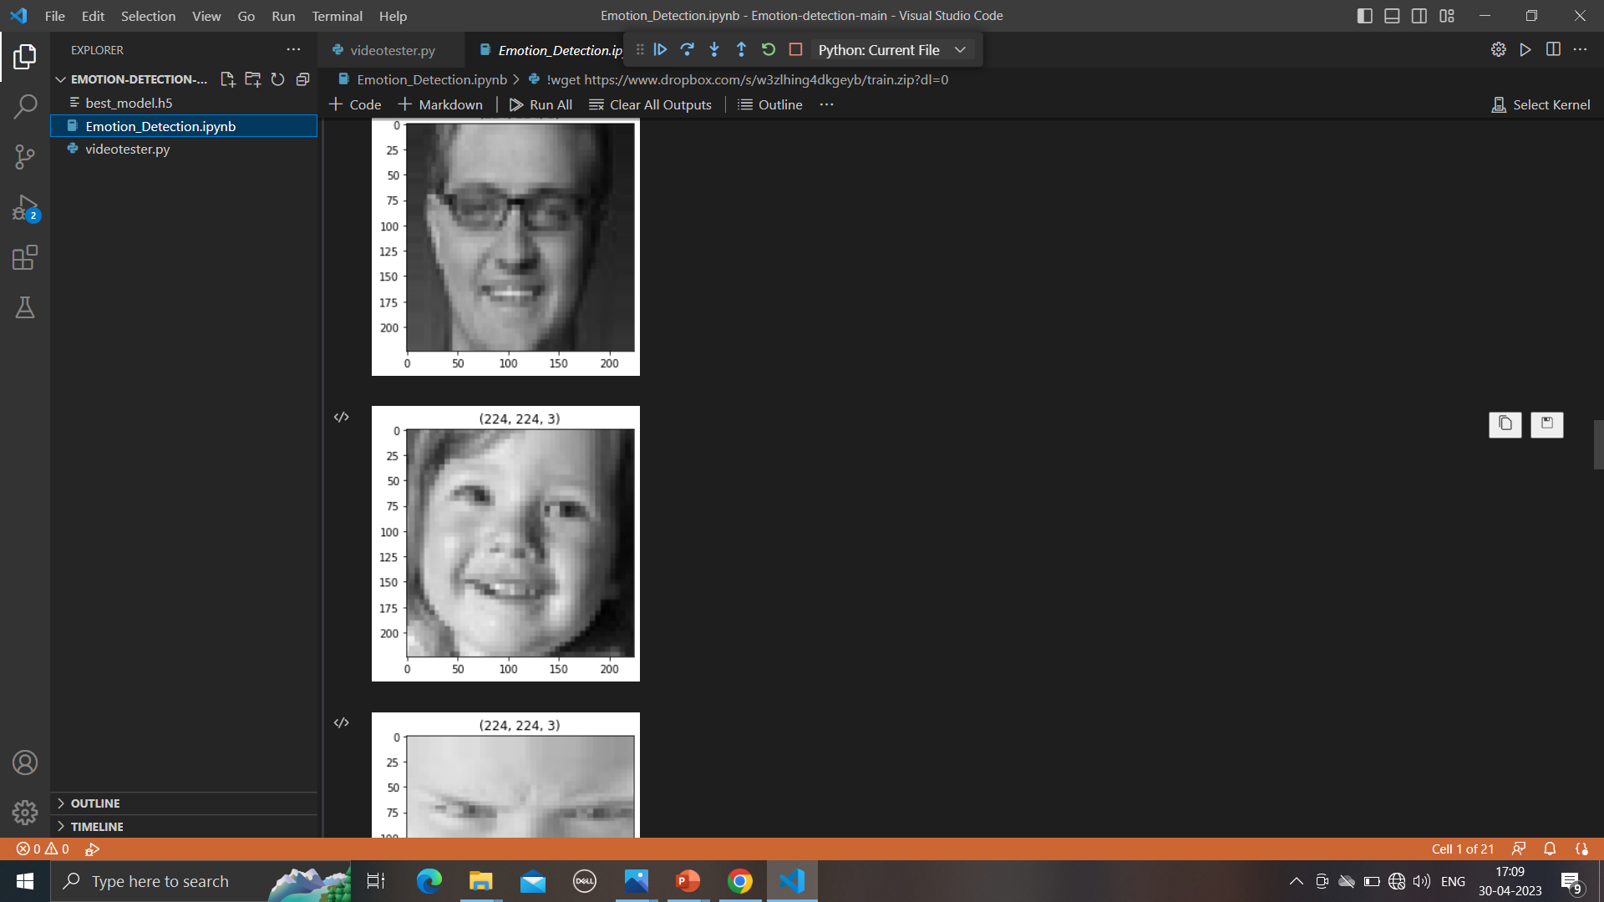

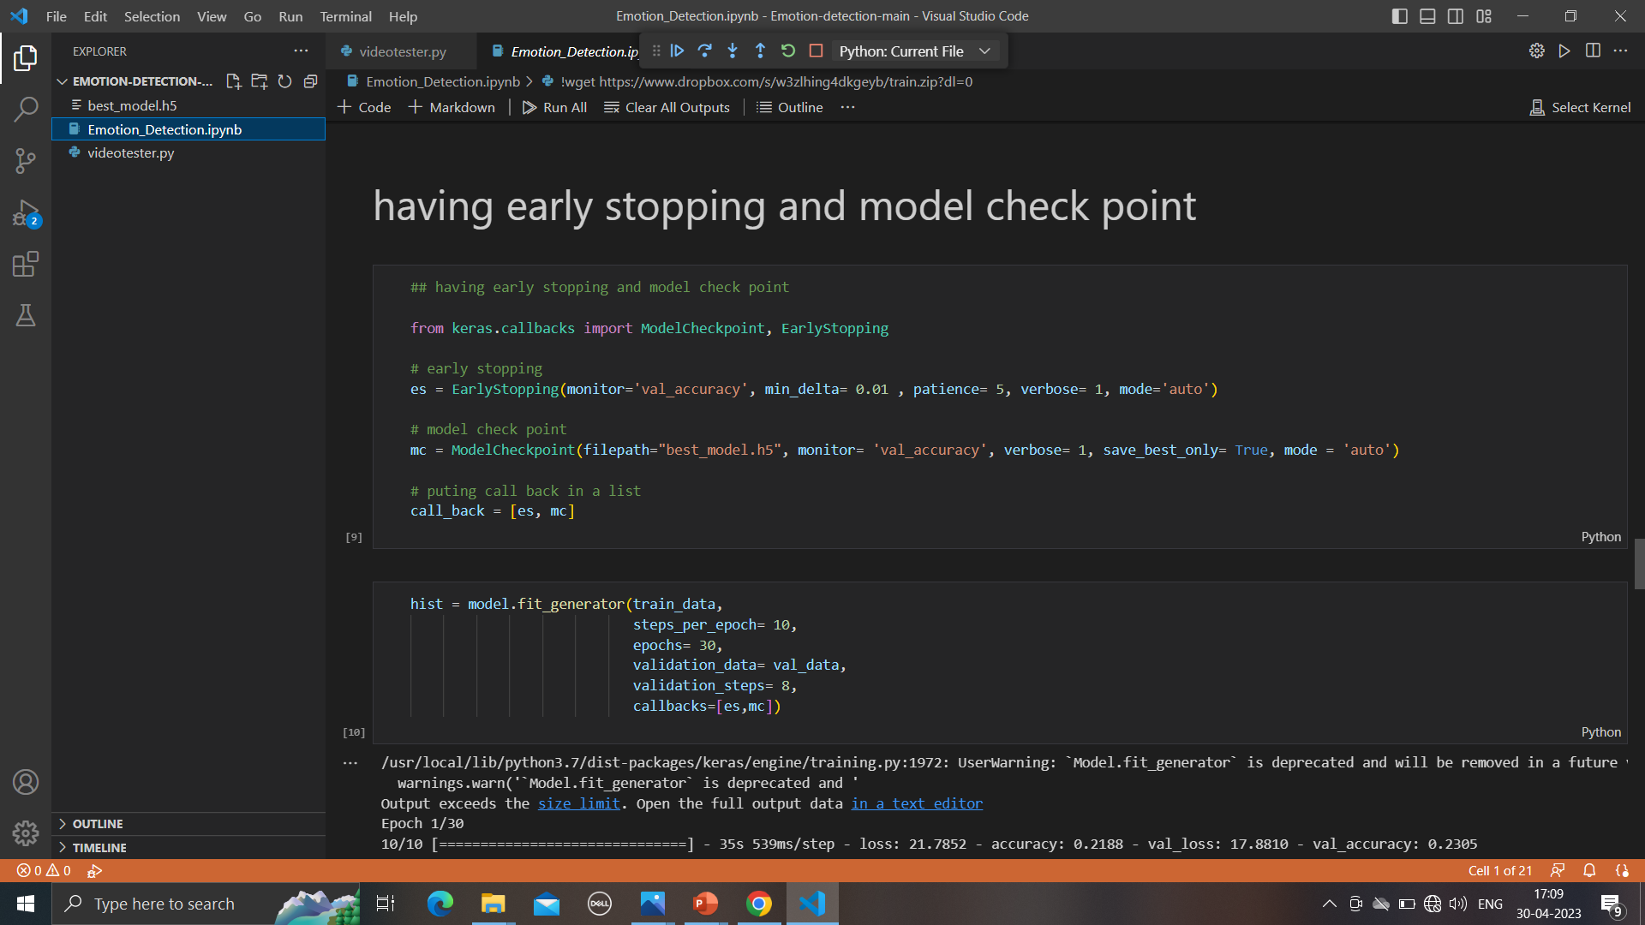

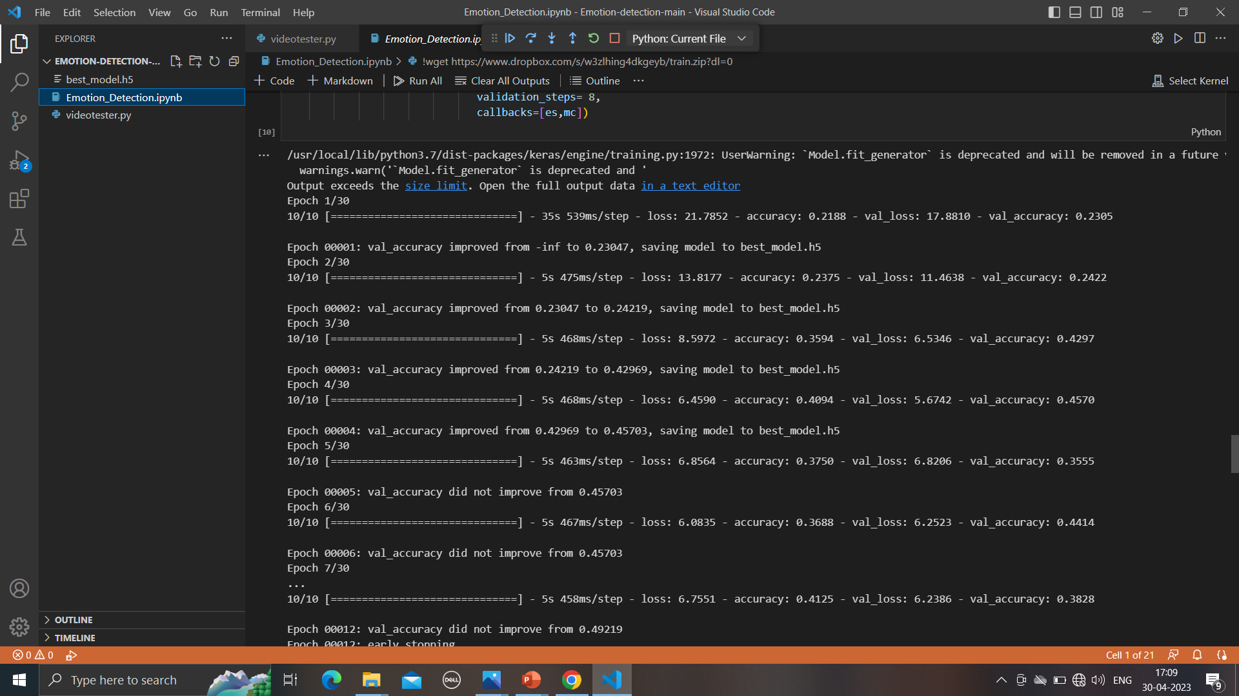

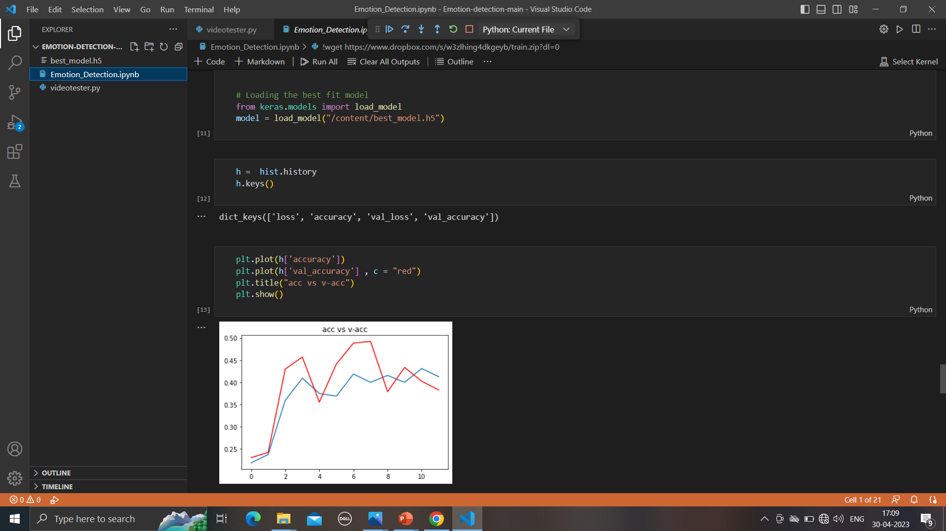

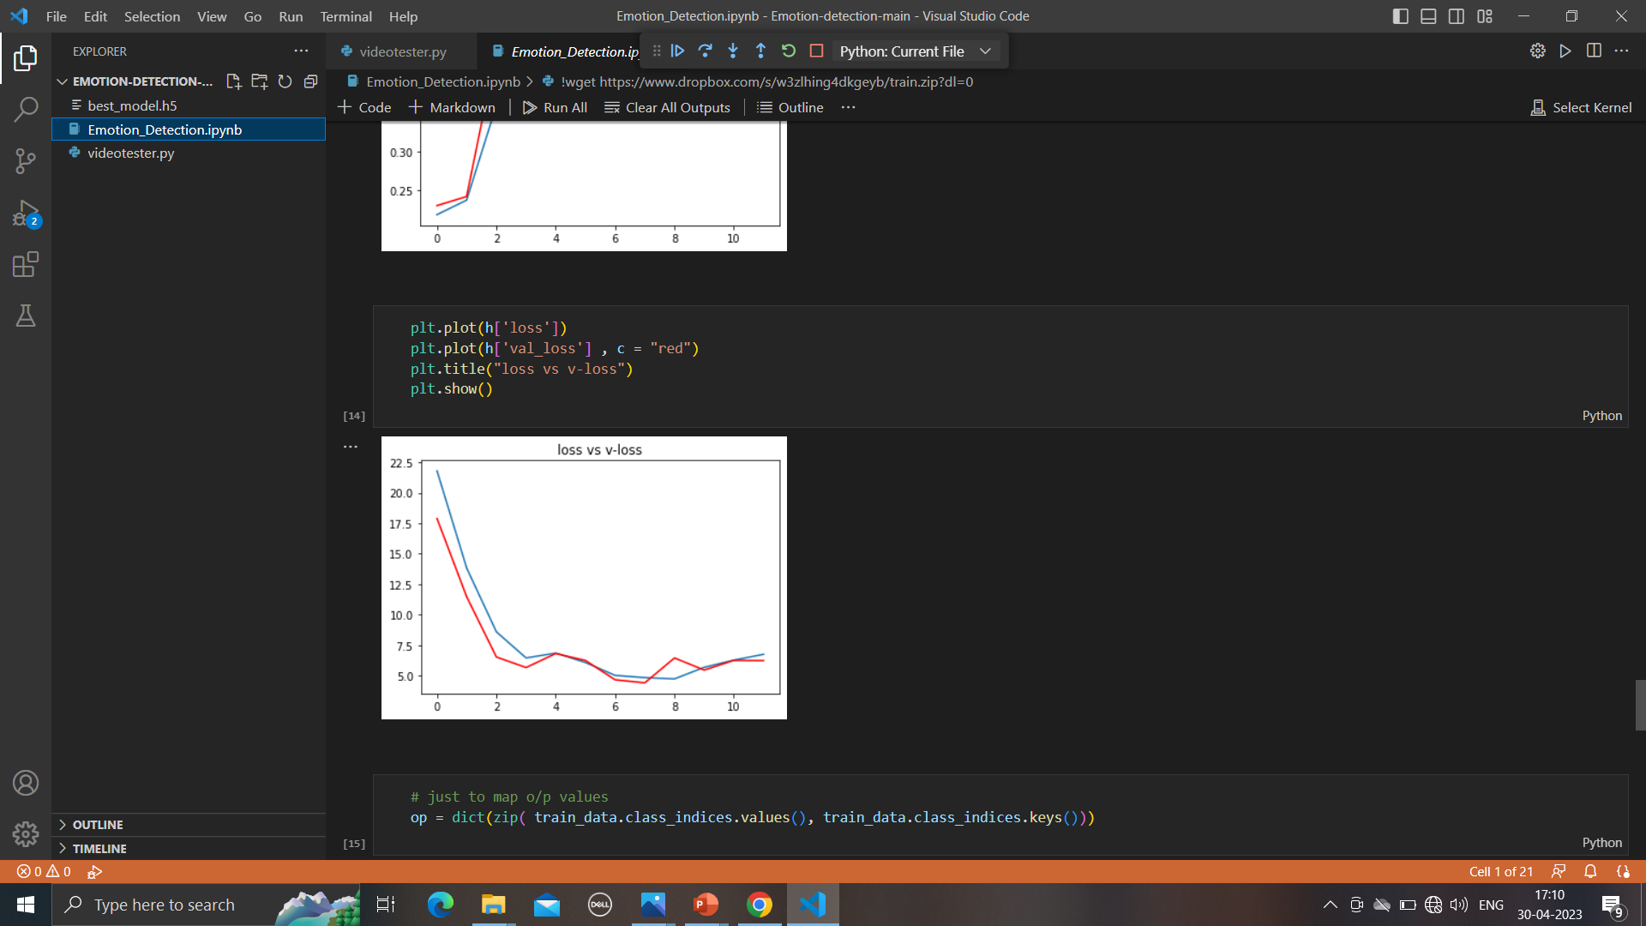

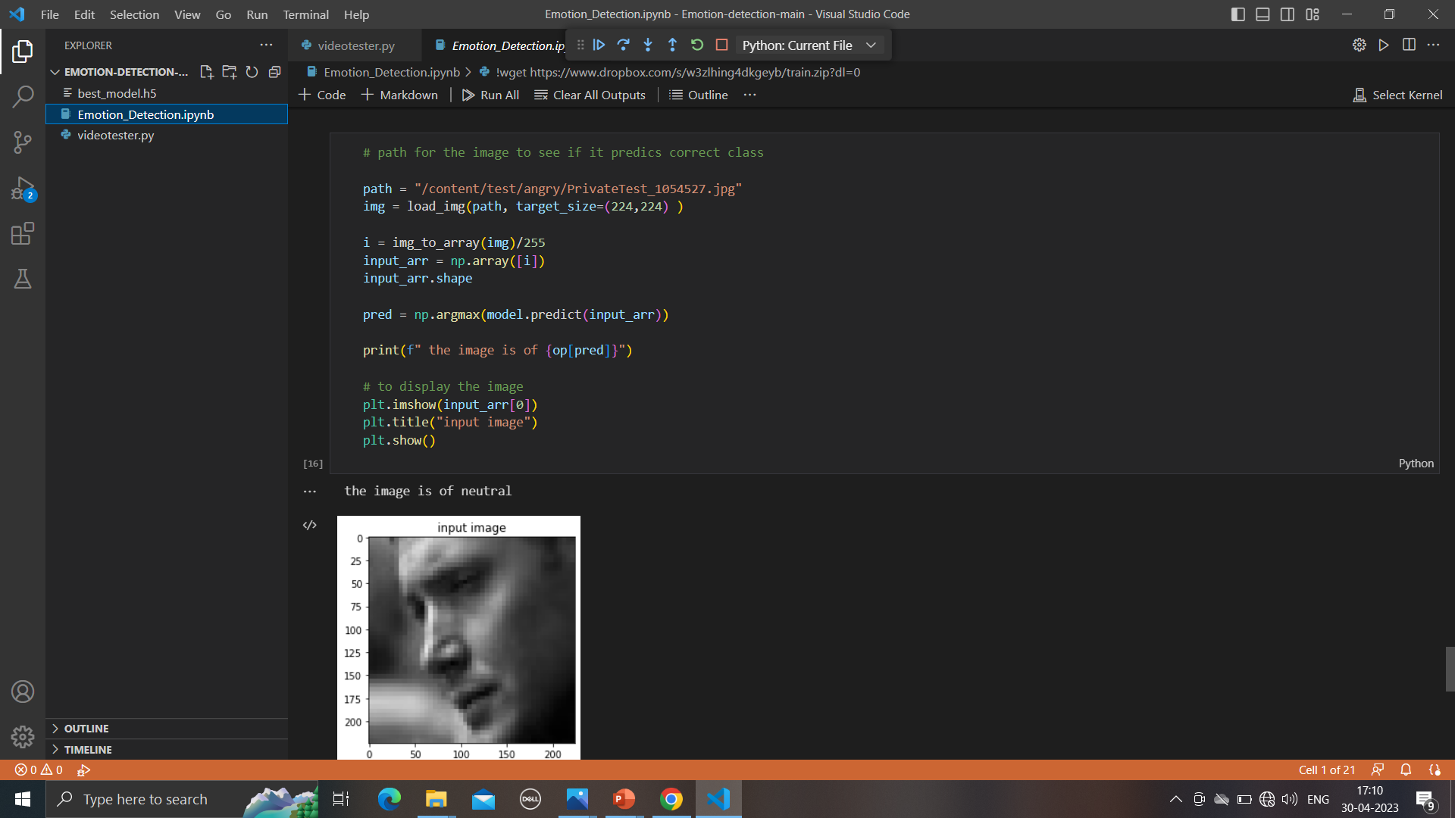H0.